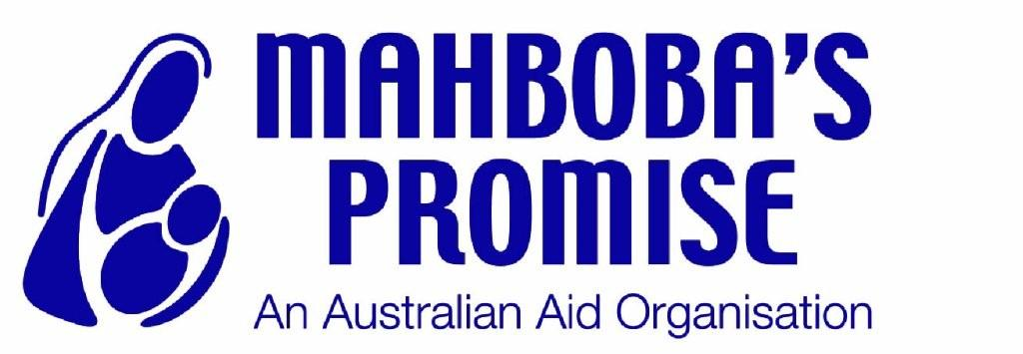

Annual report 2012-13

A message from our patron
The work of Mahboba Rawi and of everyone at Mahboba’s Promise has continued to inspire me over this past year. The value and impact of their work on the ground in Afghanistan cannot be overstated. The passion, energy and commitment with which they do their job, in often difficult circumstances, is commendable.
The organisation’s holistic approach sees them providing practical assistance and relief to the needy, as well as opening up access to education and vocational training programmes for widows and orphans. The skills gained lead individuals, families and entire communities towards a state of self sufficiency; where they are able to provide for themselves and live their lives independently.
As Afghanistan prepares for the withdrawal of troops in 2014, the work Mahboba’s Promise does to support the country’s most vulnerable has never been more important. During this time the local reputation of Mahboba’s Promise; that it is honest, free from corruption and all aid goes directly to the vulnerable individuals and communities of Afghanistan will go a long way to instilling confidence in both donors and beneficiaries.
I am proud to be patron of Mahboba’s Promise and support every effort the organisation makes to improve the lives of Afghanistan’s widows and children. Mahboba herself continues to be a source of inspiration to me, and a dear personal friend. I am lucky to have witnessed her achieve many special things in the name of her people.
Quentin Bryce

A message from our founder
Mahboba’s Message
A lot has changed for Mahboba’s Promise over the last 12 months. It has been challenging in many ways, but I am pleased to see the organisation adapting and moving forward.
It has been a difficult year for us in terms of raising funds. The tragic situation in Syria has meant some of our key donors have diverted their donations to help those suffering, and simply cannot afford to support the rebuilding of Afghanistan too. My heart breaks whenever I see suffering of this scale, anywhere in the world. But it strengthens my resolve and my focus to help create a better life for my people in Afghanistan.
In the Sydney office we have made a lot of progress towards our goal of applying for Ausaid accreditation. We have been lucky enough to see an increase in the number of highly qualified and motivated volunteers donating their time to making our organisation more effective. I am so excited to see the youth and energy in the team that have stepped up to move Mahboba’s Promise forward. The Sydney office gives me so much confidence for the future, just seeing their hard work and enthusiasm makes me sure we will continue to make a difference to the lives of the most vulnerable and needy in Afghanistan. I am so grateful to be surrounded by such a dedicated team.
Our work in Afghanistan continues to provide life saving care. We have been focusing our efforts in Kabul, Panjshir, Takhar and Parwan and have put a lot of energy over the past year into our ‘Hope Houses’. Each Hope House provides safety and a loving environment for orphans, and watching them grow up under our care makes me so proud. The centres provide the communities in which they stand hope for their futures. The existence of hope in Afghanistan remains rare, and can be life-changing.
The continued support of the Governor General of Australia means a great deal to me personally and to Mahboba’s Promise. I feel blessed to have the support of our patron’s entire office. With the right team around me I feel so hopeful for the future of Mahboba’s Promise. We will be moving forward together, united in our vision of a better future for Afghanistan.
Thank you for all of your support
Mahboba Rawi

Mission/Vision/Values
Vision
Our Vision is to provide a sustainable future within a secure environment for disadvantaged Afghan women and children.
Mission
Mahboba’s Promise aims to provide effective overseas development aid to disadvantaged Afghan women, widows, children and orphans. We will achieve this through sustainable development programs such as the establishment of schools, health clinics and community facilities destined to be operated by local authorities and communities.
Values and Principles
To achieve our Mission, we will honour the values of compassion for people in need and effectively impact on their circumstances while embracing standards of practice that ensure integrity, honesty, transparency and due diligence.
- In developing our aid programs, we will strive to:
- Build the morale of people affected by conflict so that they have motivation to reconstruct their country
- Restore faith in the future for the people of Afghanistan through the example of quality workers delivering aid services
- Consider and consult experts in relation to cultural practices and beliefs to identify and meet the best interests of Afghan women, widows, children and orphans
- Establish self-sufficiency in individuals and sustainable outcomes in community projects in the programs that we provide
- Enhance the quality of life of our beneficiaries through education and employment training
- Have effective consultation with all stakeholders including beneficiaries and value their participation in our programs
- Secure basic human rights including the principles of gender equality and child protection in our program design
- Be equitable and non-discriminatory in the distribution of our aid
- Follow best practices and give due consideration to issues of sustainable ecological and resource management in our aid programs
In our Governance, we will endeavour to be professional and accountable and compliant by:
- Offering the public and organizations in Australia and elsewhere, a trusted and acceptable mechanism by which they may contribute funds to worthy projects to assist Afghan women, widows, children and orphans
- Ensuring that the Association is at all times financially responsible
- Developing, implementing and reviewing the Policies and Procedures of the Association

Summary of Activities
Programme Highlights
Afghanistan
Afghanistan largely remains an unhappy place to live. While the country shows some positive signs, it is struggling to recover from its war torn history. To live in Afghanistan is often to live a life devoid of hope. Mahboba’s Promise seeks to reignite the spark of hope within the communities it operates.
Mahboba’s Promise addresses both infrastructure needs and the developmental needs of the communities in Afghanistan in which it is active. Mr Omar Rawi, brother of Mahboba’s Promise Founder Mahboba Rawi visited Afghanistan in mid- 2013 on a monitoring visit. Upon his return, Omar stated that the work Mahboba’s Promise does in Afghanistan is “unique... no other organisation is giving as much genuine help and hope for the future as Mahboba’s Promise”.
Mahboba’s Promise continues to deliver a holistic service that encompasses welfare provision through to development programmes aimed at teaching skills to the most vulnerable. Through its vocational training programmes and educational courses, the organisation facilitates the most vulnerable individuals eventually living self sufficient lives, supporting themselves and their families. Mahboba’s Promise still delivers projects and services in three main areas of the country; Kabul, the Panjshir Valley and Takhar. All three regions now boast fully equipped education centres that benefit the regions neediest children. Mahboba’s Promise has transformed the lives of many widows through its permaculture and related agriculture and food-security focused programmes
The Hope Houses
Two new ‘Hope House’ education centres have been established in the two areas outside of Kabul where Mahboba’s Promise is particularly active; the Panjshir Valley and Takhar. The centres are based on the existing Hope House model that continues to provide exceptional services to the community in Kabul. The fundamental objectives of the centres are twofold; to address the need of orphans and vulnerable children living on the streets or in dangerous situations by providing residential and welfare services, and to supplement existing education provisions in Afghanistan by offering additional classes. These objectives are developmental in nature as they seek to provide the orphans with a basis upon which they can build a self sufficient life in the future.
Panjshir Valley
The Hope House centre in the Panjshir Valley was generously funded by entrepreneur Mr Dick Smith. The construction of the building began in 2010 and the basic structure was completed in 2012. It has the capacity to house 100 orphans, both boys and girls and is the only centre in the area that provides living space as well as access to an improved education. In late August 2013, the building opened its doors to the community and the area’s most vulnerable children moved in to the centre to begin their new lives.
The educational component of the centre is it’s most crucial as it will help facilitate self sufficiency in the future for the beneficiaries. Designed to complement the half-day of schooling the beneficiaries already receive, each individual will be assessed and a plan which best suits their educational and developmental needs will be devised by the team at the centre. The education offered at the centre will include engaging the children in sport and recreational activities designed to boost their self esteem and confidence.
Takhar
The construction of the Hope House centre in Takhar was completed in early 2012. The centre became operational in September 2013, building on support from the local community to extend the reach of its services to all vulnerable children and children at risk. While the centre was initially conceived of as a space in which to support a group of young boys who had been orphaned by an earthquake in Takhar and subsequently taken to Peshawar, Pakistan for support, the overriding objective of the centre is to provide educational services and vocational training to the many vulnerable children in the area. Operationally, the centre is in its early stages, providing services to 20 boys and girls, and still requires significant funding commitments from our donors.

MAMA Library
The MAMA library is a component of Hope House Panjshir Valley. This was a project that was implemented by Mahboba’s Promise and funded by Make a Mark Australia (MAMA). As was acknowledged when the idea for the Hope Houses was originally conceived, education is a crucial development enabler, and the need for improved resources and breaking down the barriers to education is acute in the Panjshir Valley.
The library is unique. Offering free access to the local community and with books available covering a huge array of subjects, including children’s story books, subjects related to the school curriculum, psychology, Persian literature, English dictionaries and grammar, history, science, religion, culture, language, mathematics, and geography, the communities appreciated the prospect of the libraries. Project Manager Omar Rawi stated that the selections of books on offer in the libraries were “the best books available ... for students, kids and people of every age and gender.”
The library was opened in June 2013. A special opening day was held and local government representatives cut the opening ribbon to the centre.
Dairy Coop
The Women’s Dairy Cooperative project is a project funded by our donors Rosemary and Jeff Holt . Its basic aim is to train ten widows in animal husbandry and dairy production. Through this training, and the creation and supervision of a small Dairy Cooperative, Mahboba’s Promise is encouraging and guiding women towards self-sufficiency
By teaching the women how to make a variety of milk products, such as cheese and yoghurt, Mahboba’s Promise is helping to diversify the diet of the local community. Nurtrition continues to be a concern in Afghanistan, with a nationwide dependence on the staple food, bread, failing to provide all of the nutrients required. Malnutrition is a fact of life in Afghanistan, and children under 5 are worryingly exposed. The nutrients that the community will gain through access to dairy products will greatly reduce incidence of malnutrition in the area.
Once production reaches a subsistence level, any excess produce is used by the women to sell or trade in the local market, opening up the opportunity for the widows to make themselves and their families self sufficient. By fostering a connection with the land and the animals around them, Mahboba’s Promise is also improving the widows’ confidence, and enabling them to see a brighter future for themselves and their families.
The women were taught a wide variety of skills, including; basic hygiene processes for dairy production, traditional organically inspired dairy production, animal husbandry, poultry farming and egg sorting as well as basic business management. In the start up phase, the cooperative includes approximately 10 cows, 300 chickens and buildings for animal shelter.
The women are able to engage in small scale entrepreneurship. Currently the women dairy cooperative project is producing, eggs, milk and yogurt and presenting to local market in accordance to the local market price. Dairy and eggs are delivered to the market 3 days per week. Individuals purchasing the products from the Women’s Dairy Cooperative report high quality produce, along with an appreciation for the high level of hygiene standards employed at the cooperative.

Permaculture: Backyard Gardens
Often, when widows come to Mahboba’s Promise and ask for help, they have no way of feeding themselves and their families. This year, with funding from the Direct Assistance Programme of the Australian Embassy in Kabul, Mahboba’s Promise has given 10 widows the opportunity to learn how to grow their own vegetables, and to actually grow them in their back gardens, using established permaculture techniques. Permaculture beds have been set up in the back yards of the beneficiaries, and they are able to grow a variety of crops in order to feed themselves and their families, and sell to or trade with their neighbours. Using the permaculture processes of water conservation, soil building and pest control, the widows have reported excellent results.
Abdara Schools
The two schools that Mahboba’s Promise continues to support in Abdara this year underwent a series of improvements to improve the conditions in which the children were learning. For the boys school, this involved plastering and painting of the wall surrounding the perimeter of the school site, provision of 100 study chairs and desk and the provision of a water tank. For the girls school, the improvements involved Installation of a roof made out of iron metal sheeting, installation of a solar panel, provision of 50 study chairs and desks and the provision of a water tank. The project was designed to significantly improve the conditions in which the students receive their education; since Mahboba’s Promise identified that the students’ education provision was suffering on account of their surroundings. Factors of cold, damp and a lack of clean water and adequate security were compromising the educational experience that the beneficiaries were receiving. Through Dubai Cares funding and the implementation and completion of the project objectives it is anticipated that the educational environment will be wholly conducive to the delivery of a secure, comfortable and ultimately happy learning experience.

Mahboba’s Promise Afghanistan In Numbers
Number of widows trained in tailoring, handicrafts, beauty therapy, quilt sewing, permaculture, hygiene and sanitation? 300
Number of orphans helped (average number of children per family in Afghanisatn is 5)? 5000
% of students that can speak English? 55%
Number of children currently using library facilities? 200
Number of patients at medical clinic? 15000
Number of graduates from high school? 200
Number of kitchen gardens? 10

Mahboba’s Promise Afghanistan In Action
Mujeebullah
In 2008, Mahboba's Promise found Mujeebullah playing in a rubbish dump and eating from it. His mother died in 2007 and his father was disabled; both his legs were deformed and he could hardly walk. His father said that no orphanage would take him since he still had one parent alive. To earn a living Mujeebullah’s father was selling plastic bags in the street and had no other option but to take his son with him.
This is how Mujeebullah came to the Hope House. When he arrived he was skinny, unwell and could not speak. While at Hope House, he had the opportunity to play with children his own age and develop both mentally and physically.
Eventually his father established a shop in the downtown and can now assure his education. He decided to take Mujeebullah back and thanked Mahboba’s Promise:
“Now I can take care of my son and I show appreciation to Mahboba’s Promise for supporting him more than five years when no one else would.”
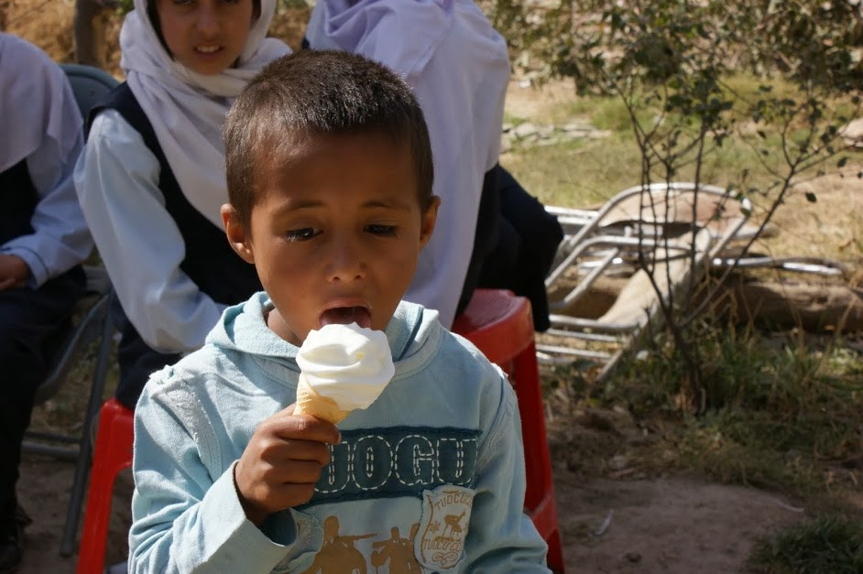
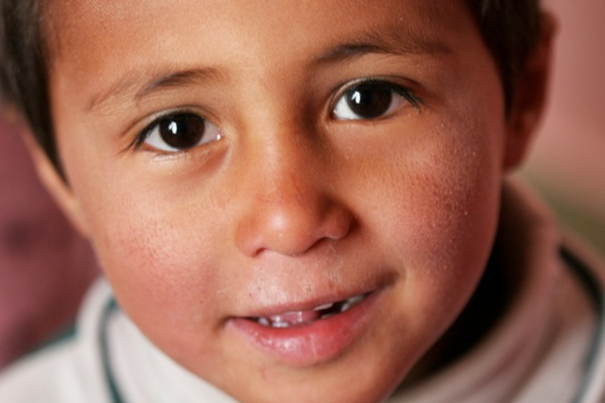
His time at Hope House gave Mujeebullah the chance to be a normal, happy child while his father was unable to care for him.

Shah Begum
“I am a 50-year-old widow with two sons and two daughters. One of my sons is at school and another works in the market. When I remember the hard times of three or four years ago, tears come to my eyes. I‘ve done a lot to keep my children alive despite great hunger.
“I used to make bread and sell it on the roads; sometimes I’d work on the land for less money. When I could not find work, I would send my children to sleep by telling them they would have food by next day.
“My doctors advised me to stop working as I have rheumatism and heart disease; I was unable to send my eldest son to school because he had to work in the market to feed us. I then borrowed some money from my relatives and bought 20 hens to sell the eggs and help the family. Thirteen of these hens died due to an unknown sickness.
“Two years ago I found Mahboba’s Promise, and they began helping me. I participated in a course and learned about hygiene. I didn’t even know how to wash my hands properly. After learning about hygiene, I taught my children what I’d learned. This year I participated in a permaculture course and learned how to use natural things instead of chemicals. I also learned about how to look after animals. I now have 10 healthy hens and sell their eggs to support the family.
“I am so thankful to Mahboba’s Promise. I have learnt a lot from them and they somehow understood me.”
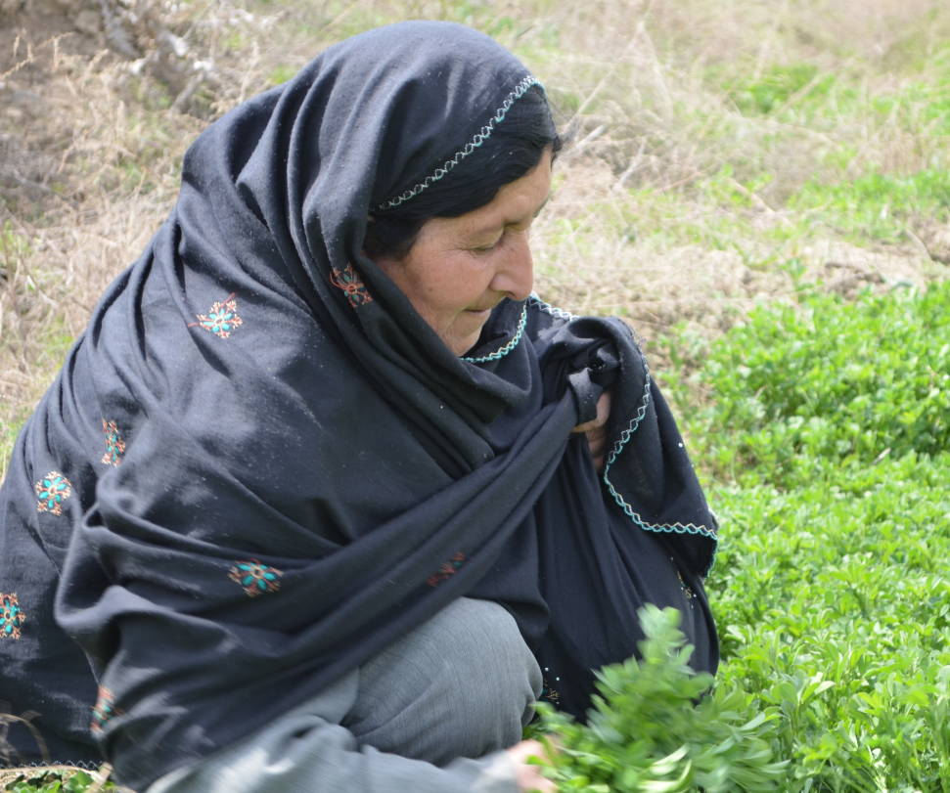
The skills that Shah Begum has learned from Mahboba’s Promise have improved the quality of life for her and her family

Sydney Office
New staff and volunteers
There have been a number of changes with regards to staffing in the Sydney Office. Al Dawood is the current Operations Manager. Carla Jolly and Sahara Basnyet are now part-time employed doing office work and general administration, and additionally continue to come to the office in a voluntary capacity. Lydia Stevens has been hired on a casual basis to formalise policies and procedures in line with Ausaid standards.
We continue to be blessed with an amazing team of volunteers, both old and new, who offer Mahboba’s Promise a wide variety of skills, their time and their energy. Our volunteers are the lifeblood of the organisation and their work is absolutely crucial. On 19/10/13, the volunteers congregated at the offices for an opportunity to meet everyone and share ideas. The meeting created a real buzz and enthusiasm.
Qurban Appeal 2013
Eid al-Adha (Feast of the Sacrifice) is one of the most important festivals in the Muslim calendar. On this occasion Muslims everywhere show their generosity, especially to the poor.
Once again, Mahboba’s Promise reached out to the Muslim community in Australia to enable the widows and orphans in Afghanistan to take part in the sacrificial meal during the period of celebration. The 2013 Qurban Appeal raised more than 17.000 AUD giving a total of 170 lambs to the poor in Afghanistan.
Crowdfunding appeal for Takhar Community Centre
Mahboba’s Promise began building a desperately needed education & community centre for Takhar children and orphans 5 years ago. The centre educates boys and girls of primary and secondary school age in literacy, numeracy and other subjects which will help them in the future. The center can accommodate 70 children but because of funding issues it currently delivering its vital services to 20 orphans. The centre needs 120,000 AUD to be at its full capacity. This is why a crowdfunding appeal was launched in September 2013 on www.fundrazr.com. We have already raised more than1000 AUD.
Social media
Mahboba’s Promise realizes just how important social media is in building connections and engaging with supporters. Mahboba’s Promise Facebook page is now active and is run by a team of marketing volunteers. Appeals, news and more contents are constantly added on the page. Mahboba’s Promise Twitter account also provides up to date news and information about the organisation. We are also in the early stages of expanding our professional network through LinkedIn. Finally, in October, Mahboba’s Promise launched a new way to raise money, with the GiveEasy application for smartphones; a quicker and easier way for donors to help Afghan women and children.
Photobooks
Mahboba’s Promise has been working on producing and publishing a set of photobooks that engagingly document each our projects to donors and supporters.
Books have so far been produced for Make a Mark Australia for their contribution to the MAMA library in Hope House Panjshir Valley, Rosemary and Geoff Holt for their donation to the Women’s Dairy Cooperative Project and Dick Smith for his donation for the construction of Hope House Panjshir Valley. Books are currently being produced for Dubai Care for the work they facilitated on the Abdara Schools, as well as for the donors who contributed to our handicraft projects.
Omar Rawi’s trip
Omar Rawi, Mahboba’s brother visited Afghanistan from July to September 2013. The purpose of Omar’s trip was firstly to analyse and judge, from an objective standpoint, the effectiveness of the work Mahboba’s Promise Afghanistan does on the ground, and report back to Sydney on its capacity. Secondly, to ensure the timely completion of a few outstanding projects and the submission of final reports to the Sydney office. Thirdly, Omar was there to oversee the work and make any relevant recommendations to the Afghanistan office for its improvement. A report has been compiled in the Sydney office detailing Omar’s major findings and recommendations. The report is an overwhelmingly positive reflection of the work being done in Afghanistan with Omar “witness[ing] first-hand the life-changing impact the work Mahboba’s Promise has”.

